ANIA Distinguished Chapter Application
To be eligible to apply for the annual Distinguished Chapter designation, all chapter annual reports and annual conflict of interest must be completed prior to the deadline.
A minimum of 10 points from at least 2 different criteria categories is required to apply. Total points possible is 24. All applications must be received by their Regional Director by January 31st.
Chapter Name: Heart of America
Criteria | Examples | Points | Requirements | Documentation | Pts
Education activities in addition to the 2 required per year (with or without contact hours) | Local (virtual or live) symposium,  roundtable discussions, speakers at a chapter meeting | 1 point per 1-hour education offering above the minimum 2 required per chapter.  Max of 6 points per year | List education event title, description, (include the minimum 2 required per chapter and all additional events), date offered, & time of offering. | Listed each activity.  Attached documentation with details or content (I.e. PowerPoint, file, minutes) or provided link to content on chapter website.
Heart of America Symposium – Live event: 9/25/2020 from 0815 – 1330 CDT. Also offered on demand from 10/1/2020-10/31/2020.  - From Big to Bigger: The Potential for “Big Data” to improve Patient Care. Paul Aylin, MBChB, FFPH, FRCPE  - Journey from Nurse Informatics to CIO. Cheryl Hertel, MBA, RN-BC, FACHE, CHCIO  - Cybersecurity in the time of COVID-19 and Beyond. Nicole Mohiuddin, MS, BSN, RN-BC & Sem Ponnambalam, MA  - Nursing Cognitive-Overload and Electronic Documentation Burden: The Current State of Science. Carolyn S. Harmon, DNP, RN-BC  Live symposium reached 52 unique individuals, and 33 additional people took advantage of the on-demand offering.  Link to recorded event:  Topic: ANIA Heart of America Chapter Symposium  Start Time : Sep 25, 2020 07:12 AM  Meeting Recording:  https://us02web.zoom.us/rec/share/kHOim0tNrtDC3__e3NinxMhcyZ8AL5tICCvXVe1XM5Cw3_XYQy8SbIw13yOJeoKf.TachJ_HNNfFVcuZC  Access Passcode: Jk5N3=2R |  |  |  |  | 2
Members present (podium or poster) at the ANIA conference or provide an ANIA webinar or publish an article for JIN during the application year | Annual Conference:  - Podium  - Preconference  - Poster presentation  National Webinar:  - 1-hour monthly webinar for ANIA members  JIN Article  - A journal article published during the application year | 1 point per poster presentation  2 points per podium or webinar presentation  points per pre-conference  points per JIN article  Max 8 points per year | List presentation(s) and presenter(s), date, and event.  Indicate the Issue, title and authors for JIN articles | Listed each presentation/article  Attached documentation with details or content (I.e. PowerPoint, file, minutes) or provided link to content.
- National Webinar: How to Successfully Work/Teach from Home: Back by Popular Demand! 6/15/2020 1500 – 1600 CDT. Elizabeth Weeks was on panel (https://library.ania.org/ania/sessions/1737/view) |  |  |  |  | 2

Criteria | Examples | Points | Requirements | Documentation | Pts
Members present informatics related topic at a non-ANIA conference (podium or poster) or provide non-ANIA webinar or publish an article (other than JIN) during the application year | Annual Conference:  - Podium  - Preconference  - Poster presentation  Webinar:  - Informatics Article  - A journal article published during the application year | 1 point per poster presentation  2 points per podium or webinar presentation  2 points per article  Max 4 points per year | List presentation(s) and presenter(s), date, and event.  Indicate the Issue, title and authors for articles | Listed each presentation/article  Attached documentation with details or content (I.e. PowerPoint, file, minutes) or provided link to content.
- Webinar for San Diego chapter: Lean 101 for Informatics. 11/11/2020 1900 – 2000 CST. Elizabeth Weeks presented  - Attached pdf of presentation slides  - Webinar for Colorado chapter: Lean Methodology for Informatics. 10/14/2020 1700-1800 CST. Elizabeth Weeks presented  - Attached minutes from chapter meeting |  |  |  |  | 4
National Involvement | - National Board Member  - Leadership Succession Committee Member  - Other National Committee Member | 1 point per member  Max of 2 points per year | Indicate the name and committee/role | Provided list and information.
- Elizabeth Weeks, ANIA President-Elect |  |  |  |  | 1
Chapter organized and offered  members the opportunity to  participate in volunteer/service or  philanthropic activities. | - Food pantry  - Clinic/shelter volunteering  - Charity walk/run | 1 point per event with 4 or more  members participating  Max of 2 points per year | Indicate the date/time of the service and the organization. Include a list of members who participated. Include a picture of the group at the event. | Attached event information including date, time, member attendee list, and photo.
Because gathering was not an option this year, we decided to include some charitable organizations in our Symposium, to give them a platform to speak to a large group of people about their organizations and their work.  - Presentation from KC Free Eye Clinic. Birju Solanki. 9/25/2020 0930 CDT.  - Presentation from First Hand Foundation. Shanna Adamic. 9/25/2020 1045 CDT.  Donated part of proceeds from Symposium to each of these organizations.  Documentation of event: see link to Symposium recording, above  Documentation of donation: Attached minutes from chapter meeting 11/4/2020. See “Symposium Recap”, under expenses. |  |  |  |  | 2
Member engagement: | Social events  Networking events | 1 point per event  Max of 2 points per year | Indicate the type of event, date and time and a picture of the group at the event. | Attached photo and event information.  Attached proof of event communication on ANIA chapter website or ANIA Connect.
- December STIR – social/networking mixer. Virtual. 12/2/2020 1800 – 1900 CST  - Attached minutes from December S.T.I.R. mixer/networking event  - Front page of website, and listing on the right under Chapter Events: 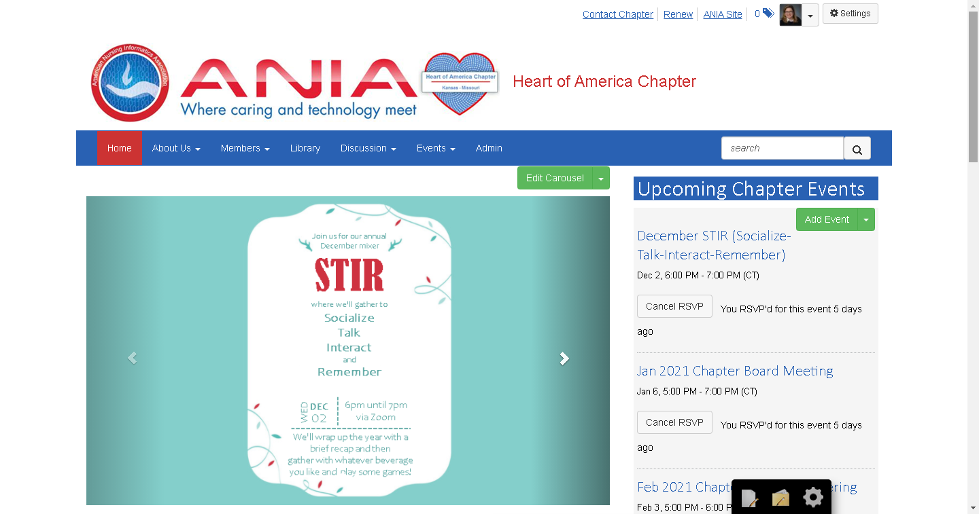  - Posted on Chapter Discussion: https://community.ania.org/heartofamerica/ourdiscussiongroup/viewthread?MessageKey=f147064f-2a97-408e-a9c9-6d90a7fd51d0&CommunityKey=75b5d3b3-f28e-4c2f-a323-e9f52173e8d2&tab=digestviewer#bmf147064f-2a97-408e-a9c9-6d90a7fd51d0  - 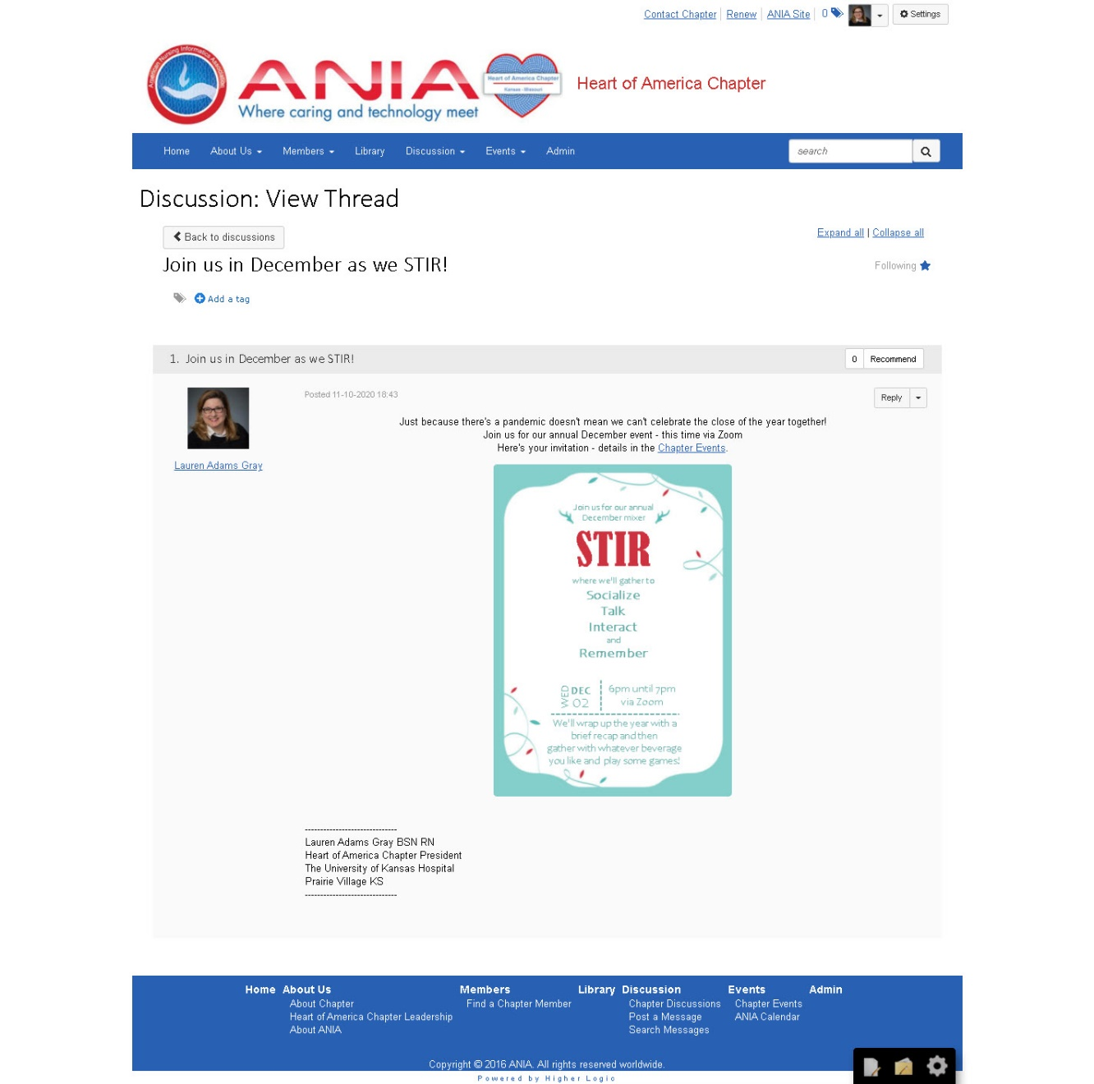  - Screenshot of the Zoom as we were getting started: 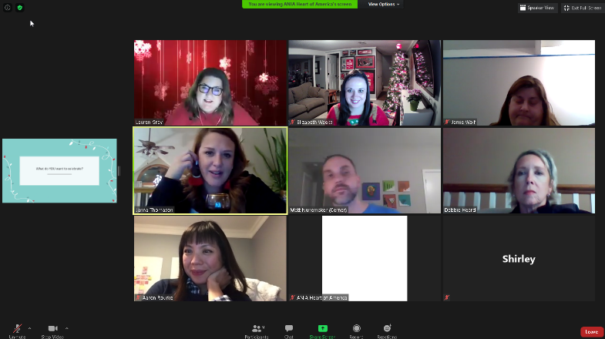 |  |  |  |  | 1
*All activities must take place within the calendar year.

Submitted by: __Lauren Adams Gray_________________________ Date: __1/29/2021_________________________

Flyer
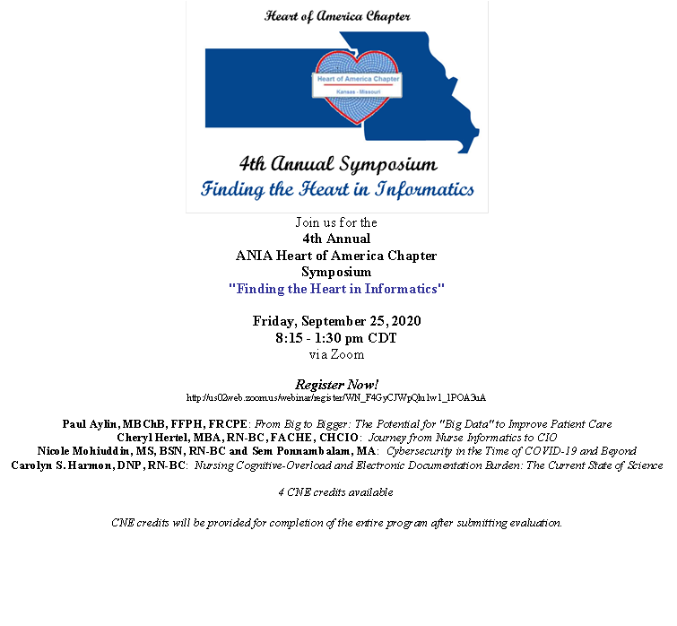

Agenda
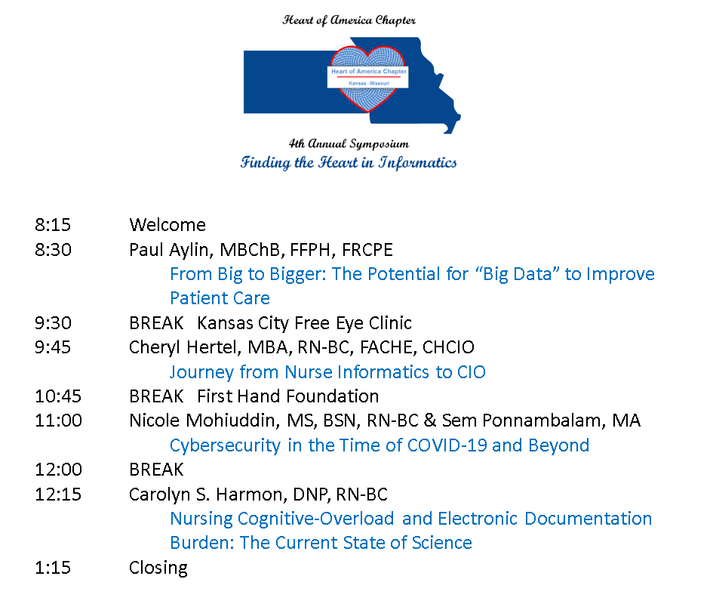
December STIR - front page of Chapter website

December STIR – Event page on chapter website
