Houston ANIA meeting October 27th, 2017
UT Health School of Nursing
Breakfast/meeting starts at 8:30 am in Room 140

Closest parking lot is TMC Garage 2

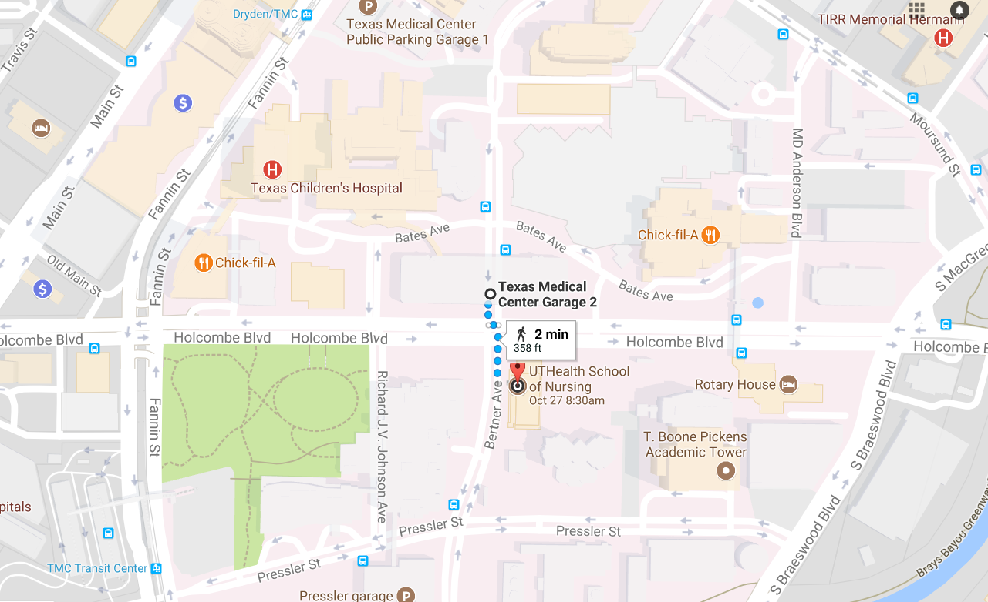

UT Health School of Nursing
6901 Bertner
Houston, TX 77030
https://goo.gl/maps/dHTzmSy46Ny

