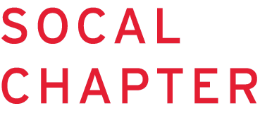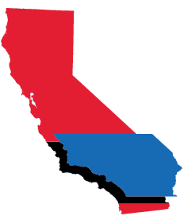

## HOLD THE DATE !

## Nursing Informatics Seminar &

## Membership Meeting

January 15, 2016

*Full day event*

Details coming soon!