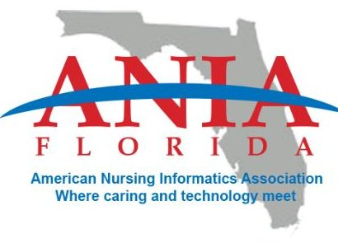
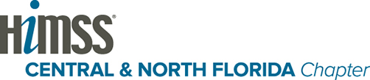

HIMSS national and the Florida Chapter of HIMSS recognizes the need to assist and support all healthcare stakeholders to ensure that HIMSS policy principles are enacted into laws and regulations to transform our healthcare system using IT. We are prepared to devote our available resources to help make these policy principles a reality.

The Central North Florida and the South Florida HIMSS Chapters are proud to announce that we have joined forces in developing and executing a state HIT Day event at our state capitol in Tallahassee, during the Florida Health Information Technology Week 2015.

Event Date: March 23 & 24, 2015
Location: Tallahassee, Florida\

Please save the date for this exceptional educational event.
More information is soon to come regarding event registration and the event agenda.

Event Date: March 23 & 24, 2015
Location: Tallahassee, Florida

Kind Regards,

Krista Potthast-Haynes
kp_haynes@yahoo.com
Co-Chair CNFL HIMSS
Advocacy & Public Policy Commitee
